Homework #3
EE:4077 Fundamentals of Machine Learning

Kernel SVM [20 points]
In this question, we consider the kernel version of SVMs, which has the following primal formulation:
$$\min_{w,b,ξ_{i}}{\frac{1}{2}{\left\|w\right\|}_{2}^{2}+C\sum_{i=1}^{n}{ξ_{i}}}$$
$$such that y_{i}\left(w^{T}ϕ\left(x_{i}\right)+b\right)≥1-ξ_{i}, ∀i=1,⋯,n$$
$$and ξ_{i}≥0, ∀i=1,⋯,n$$
where $x_{i}∈R^{p}, i=1,2,⋯,n$ is the original training data associated with the label $y_{i}∈ \{-1,1\}$, $C > 0$ is a constant, and the function $ϕ : R^{p}→ R^{d}$ maps the original data $x_{i}$ to a new feature vector $ϕ(x_{i})$ in $R^{d}$. We optimize over the model weights $w ∈ R^{d}$ and $b ∈ R$, as well as the slack variables $ξ_{i} ∈ R, i = 1,2,⋯n.$
- [5 points] Recall that the dual formulation of the SVM problem can be written as

$$\max_{α}{\sum_{n}{α_{n}}-\frac{1}{2}\sum_{m,n}{y_{m}y_{n}α_{m}α_{n}{ϕ\left(x_{m}\right)}^{T}ϕ(x_{n})}}such that \sum_{n}{α_{n}y_{n}}=0, 0<α_{n}<C$$
where$α_{n}$ denotes the dual variables. Suppose we have obtained the solution of the dual problem, denoted as $α_{i}^{*}$ for $i = 1,2,⋯n.$ In lecture, we saw that when we do not define the transformation $ϕ$, the optimal $w^{*}$ and $b^{*}$ can be written in terms of the optimal dual variables $α_{i}^{*}$. Given the SVM formulation with the transformation $φ$ as above, find $w^{*}$ and $b^{*}$ in terms of the optimal dual variables $α_{i}^{*}$.
- [4 points] How does the dual formulation change when we use kernel functions, i.e., $k(u,v),$ defined over a pair of inputs (u$,v)$? The kernel function $k(u,v)$ measures similarity between inputs $(u,v).$
- Consider a test data point $z ∈ R^{p}$. We wish to use the kernel SVM classifier derived above to make a classification decision for $z$.

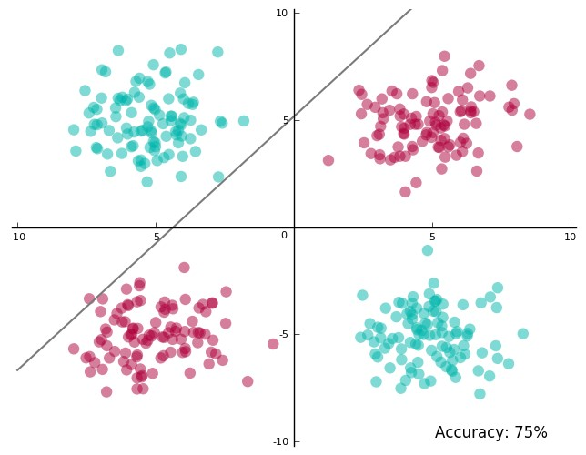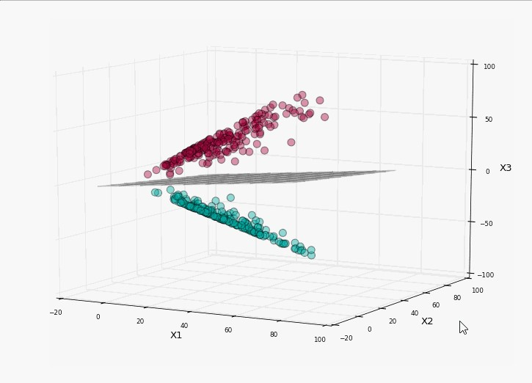
(a) Original dataset. (b) Transformed dataset.
Figure 1: Example of original and transformed data for Q1c.
  - [3 points] Under what conditions would we classify $z$ as having the label 1?
  - [4 points] Suppose that the mapping $ϕ(x)$ is given by the following for $x = {[x_{1},⋯,x_{p}]}^{T}:$

$$ϕ\left(x\right)={\left(\underset{length p}{\underbrace{x_{p}^{2},x_{p-1}^{2},⋯,x_{1}^{2}},}\underset{length p-1}{\underbrace{\sqrt{2}x_{p}x_{p-1},⋯,\sqrt{2}x_{p}x_{1}}},\underset{length p-2}{\underbrace{\sqrt{2}x_{p-1}x_{p-2},⋯,\sqrt{2}x_{p-1}x_{1}}},⋯,\sqrt{2}x_{2}x_{1}\right)}^{T}$$

Note that the variable under the brace denotes the number of terms in the brace. For example, if $p = 2$, then

$$ϕ\left(x\right)={\left(x_{2}^{2},x_{1}^{2},\sqrt{2}x_{2}x_{1}\right)}^{T}$$

which transforms the 2-dimensional dataset shown in Figure 1a (not linearly separable) to the linearly separable 3-dimensional dataset in Figure 1b.
What is the time complexity of making the classification decision (i.e., how does the number of operations required to compute the condition above grow with $p$)? Write your answer using big-O notation.
  - [4 points] Define the kernel function $K(u,v) = {ϕ(u)}^{T}ϕ(v$) where $ϕ(·)$ has the same definition as above. What is the time complexity of making the classification decision if we directly compute $K(·,·)$ without computing $ϕ(u)$ and $ϕ(v)$? How does this compare to the complexity when we directly compute $ϕ$ as above?
Hint: When $p = 2$, it is easy to see that $K\left(u,v\right)= u_{1}^{2}v_{1}^{2}+2u_{1}u_{2}v_{1}v_{2}+u_{2}^{2}v_{2}^{2}={\left(u^{T}v\right)}^{2}$. Can you generalize this expression for $p > 2$?

Double Counting the Evidence [20 points]
Consider the two-class classification problem where the class label $y ∈ \{0;1\}$ and each training example $X$ has 2 binary attributes $X_{1},X_{2} ∈ \{0;1\}$. Let the class prior be $P(Y = 1) = 0.5$ and let

$P(X_{1} = 1 | Y = 1) = 0.8$, $P(X_{1} = 0 | Y = 0)= 0.7$,
P($X_{2}$ = 1 | Y = 1) = 0.5, P($X_{2}$ = 0 | Y = 0) = 0.9.

So, attribute X₁ provides slightly stronger evidence about the class label than X₂.

- [6 points] Assume $X_{1}$ and $X_{2}$ are truly independent given $Y$. given $X_{1}= x_{1}$ and $X_{2}= x_{2}$, write down the Naive Bayes decision rule. Fill out the following table of predictions, $f(X_{1},X_{2}) ∈ \{0,1\},$ based on the Naive Bayes decision rule for each of the 4 settings for $X_{1},X_{2}$. Please show your calculations.

$$X_{1}$$ | $$X_{2}$$ | $$f(X_{1},X_{2})$$
0 | 0
0 | 1
1 | 0
1 | 1

- [6 points] For the Naive Bayes decision function $f(X_{1},X_{2})$, the error rate is:

$$\sum_{X_{1},X_{2},Y}{I\left(Y≠f\left(X_{1},X_{2}\right)\right)P(X_{1},X_{2},Y)}$$

where $I(Y≠ f\left(X_{1},X_{2}\right)) = 1$ if $Y ≠f(X_{1},X_{2})$ and 0 otherwise. For this question, we will assume that the true data distribution is the same as the Naive Bayes distribution, so $P(X_{1},X_{2}|Y )$we can be written as $P(Y )P(X_{1} | Y )P(X_{2} | Y )$. Show the error rate of the Naive Bayes Classifier is 0.235.

- Now, suppose that we create a new attribute $X_{3}$, which is an exact copy of $X_{2}$. So, for every training example, attributes $X_{2}$and $X_{3}$ have the same value, $X_{2} = X_{3}$.
  - [2 points] What is the error rate of Naive Bayes now, using $X_{1}$, $X_{2}$, and $X_{3}$? The predicted $Y$ should be computed using the assumption of conditional independence, and the error rate should be computed using the true probabilities. Bunda X3 ileX2 yi aynı değerler olarak yazıyoruz tabloda yan yana daha sonra da tabloda tekrar error rate olan kısımları yani tabloda olmayanları alıyoruz.
  - [2 points] Why does Naive Bayes perform worse with the addition of $X_{3}$?
Hint: Does the key assumption of Naive Bayes still hold?
  - [2 points] Now consider a logistic regression model $M$, with weight vector $w = [w_{1},w_{2}]$ that is used to predict $Y$ using $X_{1}$ and $X_{2}$ and another model $M^{'}$, with weight vector $w^{'}=\left[w_{1}^{'},w_{2}^{'},w_{3}^{'}\right]$ that is used to predict $Y$ using $X_{1}$, $X_{2}$, and $X_{3}$. What is the relation between $w$ and $w^{'}$ after training both models?
  - [2 points] Will the trained logistic regression model $M^{'}$ suffer from the same problem as the Naive Bayes model in part (a)? Explain why or why not.

Gradient Descent for Logistic Regression [50 points]
In this problem, you will implement (unregularized/regularized) logistic regression for binary classification problems using gradient descent. Note that you may not use any libraries/packages that implement gradient descent - you must implement it yourself. Cross validation is NOT needed for this programming assignment. For all plots you make, you MUST provide title, x-label, y-label, and legend (if there is more than one curve). Note that you need to submit your source code as part of the homework PDF that you submit.

Dataset
This dataset contains 392 instances and each of them is labeled as either a high or low gas mileage car. Each data instance is a vector with the following 6 variables , and your goal is to classify a car as “high” or “low” gas mileage.

Gas mileage: 1 (High) or 0 (low)
cylinders: Number of cylinders between 4 and 8
displacement: Engine displacement (cu. inches)
horsepower: Engine horsepower
weight: Vehicle weight (lbs.)
acceleration: Time to accelerate from 0 to 60 mph (sec.)

We have already divided this dataset into training and test datasets, and each of these datasets is stored in two distinct folders (one corresponding to low and the other corresponding the high gas mileage). In other words, to build your model, you need to iterate through all the vectors within /Train/high_gas_mileage_train.csv and /Train/low_gas_mileage_train.csv, and to test your model you need to iterate through /Test/high_gas_mileage_test.csv and /Test/low_gas_mileage_test.csv

Feature Representation
An essential part of machine learning is to build the feature representation for raw input data, which is often unstructured. Once we construct the features, each data instance x_{i} can be represented as:
$$x_{i} = (x_{i1},⋯,x_{id})$$
where $x_{ij}$ denotes the jth feature for the ith instance.
In this problem, each data instance is already in the feature vector representation form. We are trying to predict the gas mileage category of a car by using 5 five attributes (cylinders, displacement, horsepower, weight, acceleration). Hence, each data instance in the dataset is a 6-dimensional vector whose first component gives the label, and the remaining components are the attributes.

Implementation
The regularized cross-entropy function can be written as:
,
where $x_{i} ∈ R^{5}$, $w ∈ R^{5}$, and $σ(·)$ is the sigmoid function. $λ$ is the regularization coefficient and $b$ is the bias parameter. Note that we don’t regularize the bias term $b$. Please use the following configuration when implementing batch gradient descent below.
Stopping Criteria. Run for 100 iterations.
Step size. Use a fixed step size (i.e., set the step size to a constant number).
Initialization. Initialize the weight $w$ to zero vector, and b to 0.1.
Extreme Condition. It is possible that when $σ(b+w^{T}x$) approaches 0, log$(σ(b+w^{T}x))$ goes to -infinity. To prevent such case, please bound the value $σ(b + w^{T}x)$ to be larger than the small constant value, ${10}^{-16}$. You can use the following logic in your code:

tmp = σ(b + w^{T}x)
if tmp < ${10}^{-16}$ then tmp = ${10}^{-16}$
Similarly, you may need to bound the value of $1 - σ(b + w^{T}x)$ when $σ(b + w^{T}x)$ is close to 1.

Batch Gradient Descent
(Q3.4a) [15 points] Write down the gradient descent updates for $w$ and $b$, for both unregularized logistic regression and regularized logistic regression. To be more specific, at iteration $t$ using the label $y_{i}∈ \{0,1\}$ and the training data points $X = [x_{1},x_{2},⋯,x_{n}],$ where $xi = [x_{i1},x_{i2},⋯x_{i5}]$, how do we compute $w^{t+1}$ and $b^{t+1}$ from $w^{t}$ and $b^{t}?$
(Q3.4b) [15 points] For step sizes η = {0.001,0.01,0.05,0.1,0.5} and without regularization, implement batch gradient descent (using the whole training data for the gradient calculation).
- Plot the cross-entropy function value with respect to the number of iterations $(T = [1,⋯,100])$ for the training data for each step size.
- Report the $L_{2}$ norm of the vector $w$ after 100 iterations for each step size $η_{i}$(fill in the table below).

Step size | $$η = 0.001$$ | $$η = 0.01$$ | $$η = 0.05$$ | $$η = 0.1$$ | $$η = 0.5$$
$L_{2}$ norm (without regularization)

(Q3.4c) [20 points] For step sizes η = {0.001,0.01,0.05,0.1,0.5} and with regularization coefficients λ = {0,0.1,0.2,0.3,0.4,0.5}, do the following:
- Setting $λ = 0.1$ plot the cross-entropy function value with respect to the number of iterations $T = [1,⋯,100]$ for the training data for each step size.
- Setting $η = 0.01$, report the $L_{2}$ norm of the vector $w$ after 100 iterations for each regularization coefficient $λ_{i}$ (fill in the table below).

Regularization parameter | $$λ = 0$$ | $$λ = 0.1$$ | $$λ = 0.2$$ | $$λ = 0.3$$ | $$λ = 0.4$$ | $$λ = 0.5$$
$L_{2}$ norm (with $η = 0.01$)

- Plot the cross-entropy function value with respect to $λ = 0, 0.1,⋯,0.5$ for the test data when $η = 0.05$.

SVMs: Hinge loss and mistake bounds [10 points]
Suppose we build a predictive model $\hat{y}= f_{w}(x) = sgn(w^{T}x),$ where $sgn(z) = 1$ if $z$ is positive and -1 otherwise. Here we are dealing with binary predictions where each label is in {−1,1}. The classification loss counts the number of mistakes (i.e., points where $\hat{y}≠ sgn(w^{T}x)$) that we make with $w$ on a dataset. The SVM loss function can be viewed as a relaxation to the classification loss. The hinge loss on a pair (x,y) is defined as:

$$l\left(\left(x,y\right),w\right)=max⁡[0,1-y(w^{T}x)]$$

where $x ∈ R^{D}$, $w ∈ R^{D}$, and $y ∈ \{-1,1\}$. The SVM attempts to minimize:
$$\frac{1}{N}\sum_{i=1}^{N}{l\left(\left(x_{i},y_{i}\right),w\right)}+λ{\left\|w\right\|}^{2}$$
where λ ≥ 0 is the regularization parameter.
Suppose that for some $w$ we have a correct prediction of $y_{i}$ with $x_{i}$, i.e., $y_{i} = sgn(w^{T}x_{i})$. What range of values can the hinge loss, $l\left(\left(x,y\right),w\right)$, take on this correctly classified example? Points that are classified correctly and which have non-zero hinge loss are referred to as margin mistakes.

If you are unfamiliar with big-O notation, this blog post has a good tutorial: https://rob-bell.net/2009/06/ a-beginners-guide-to-big-o-notation/.

